**TASK 4: Create an ALB and map the instances under ALB.**

1. **With the DNS of ALB, the webserver should be get accessed**

**Steps to create ALB (Application Load Balancer) and map instances under ALB:**

1. In AWS console home search Load Balancers and go to the Load Balancer EC2 feature**.**

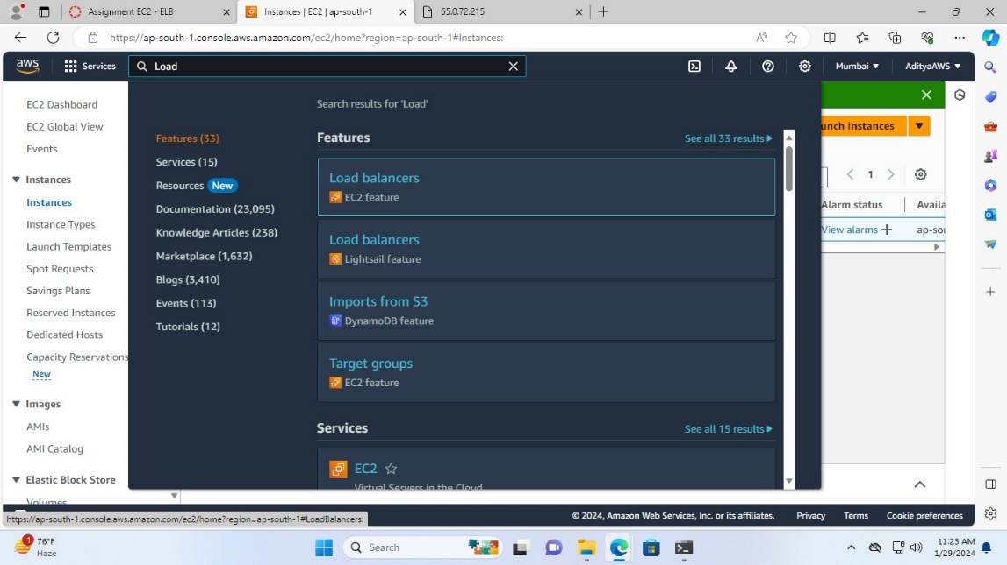

1. Now click on “Create load balancer”

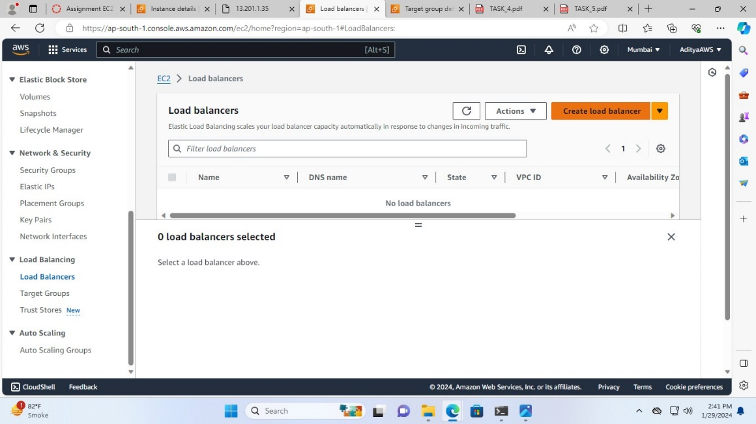

1. Select Application Load Balancer in load balancer type and click on “Create”.

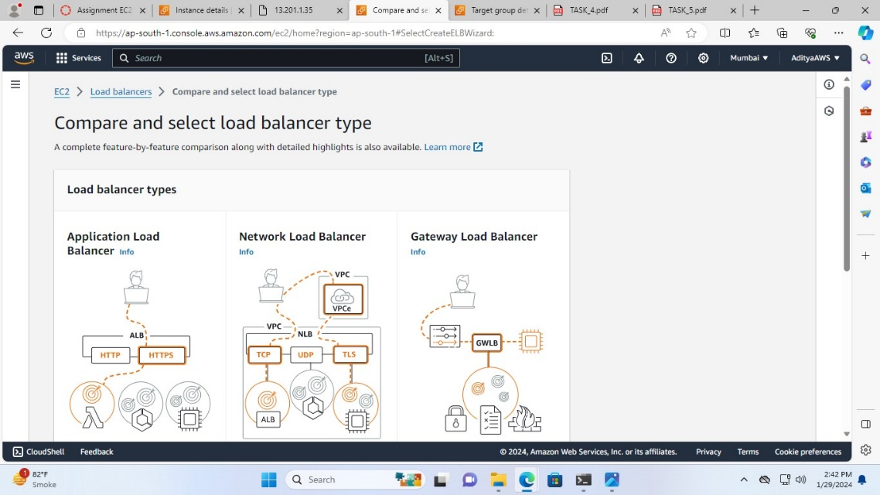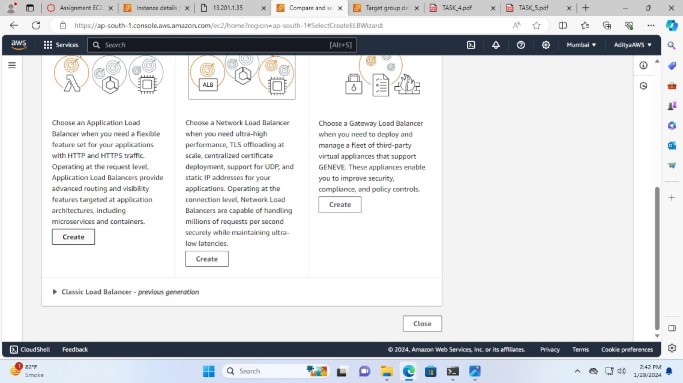

1. Name the Load balancer as I have named it task-loadbalancer

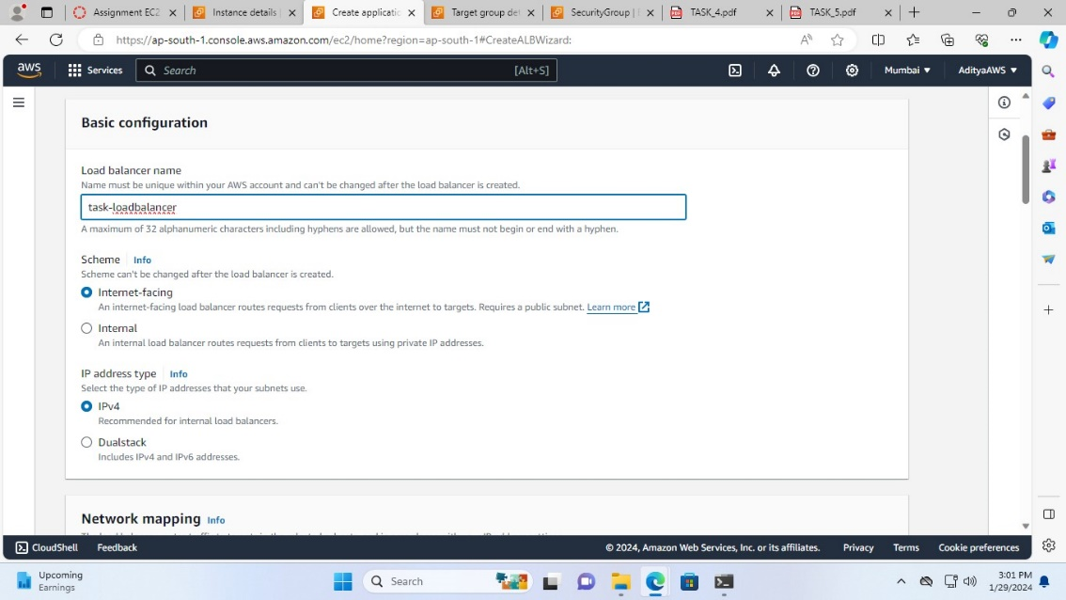

1. In Network mapping leave VPC as it is, and select all zones

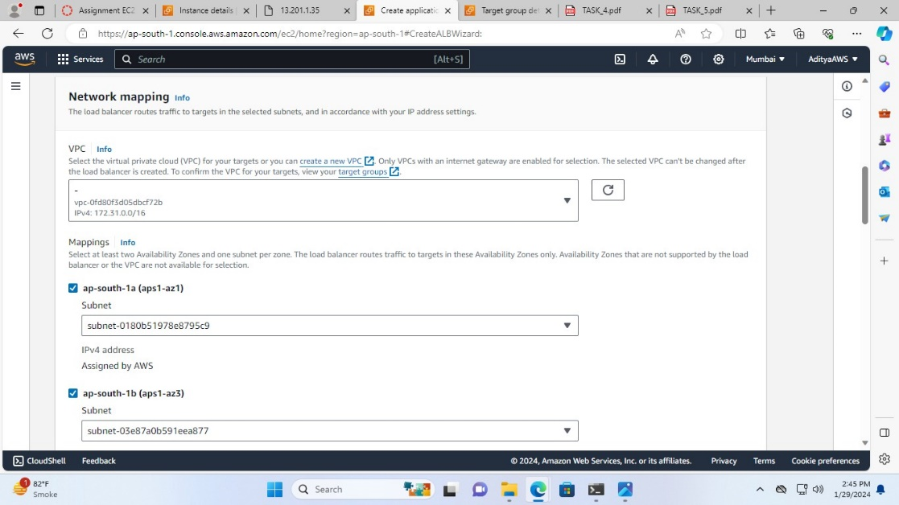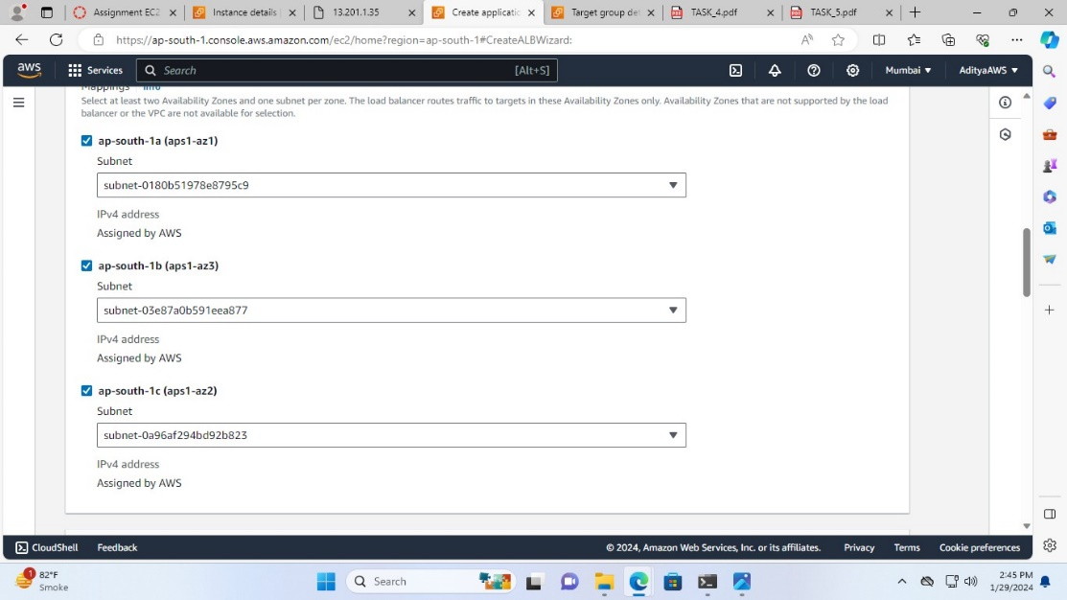

1. In security groups click on “Create a new security group”

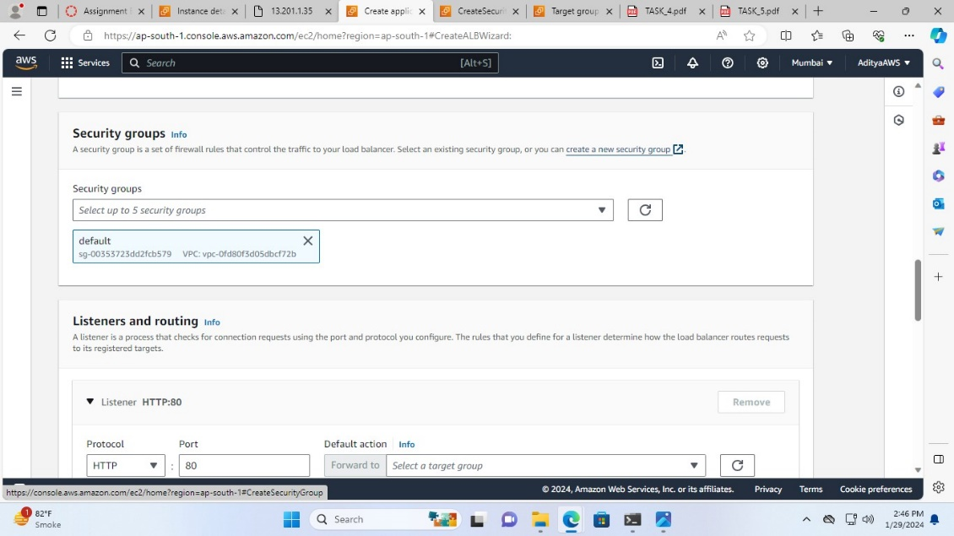

1. Name the security group (task-security-group), add a description and in inbound rules section click on “Add rule” and select HTTP in type, in source for any choose 0.0.0.0/0 leave outbound rules with no change.

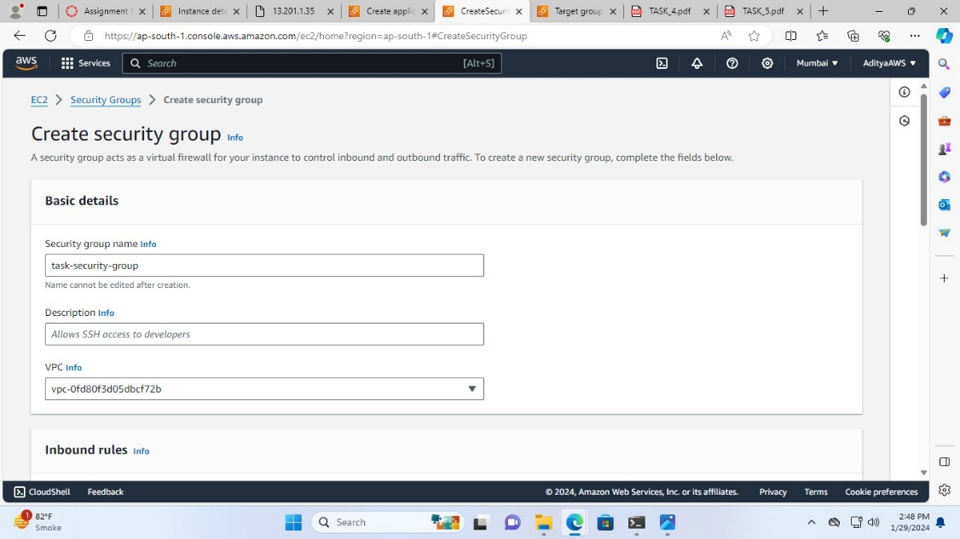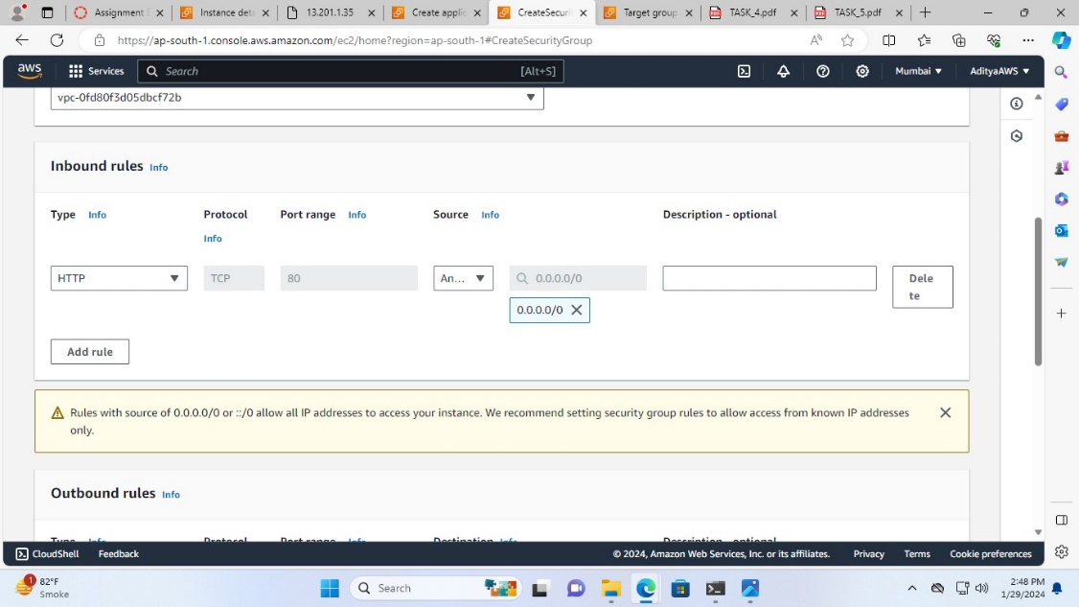

1. Then, click on “Create security group”.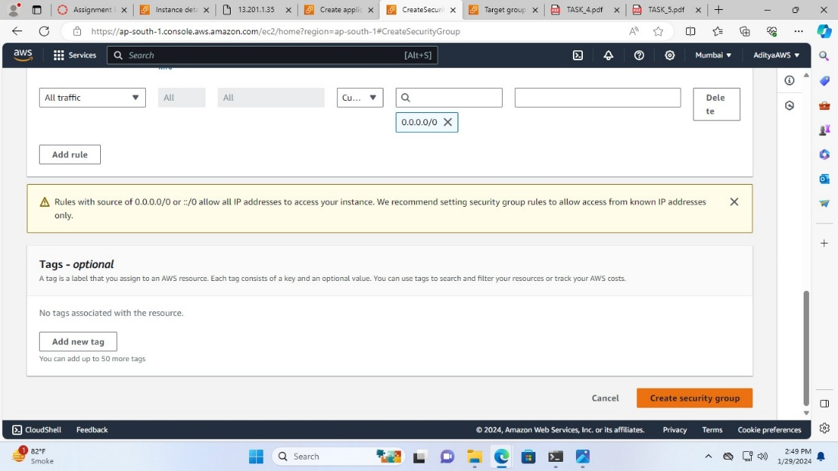

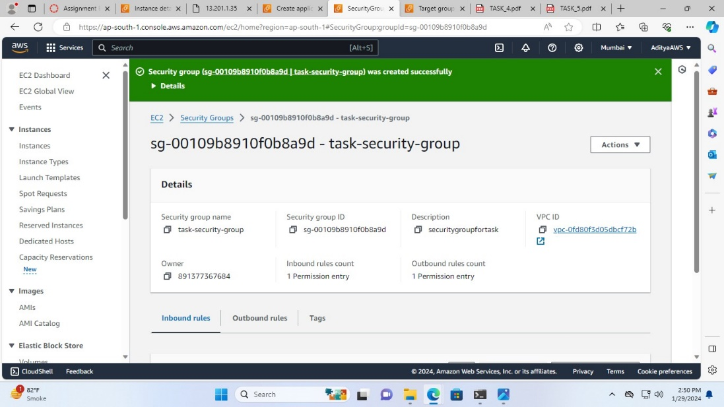

1. Now, select this security group

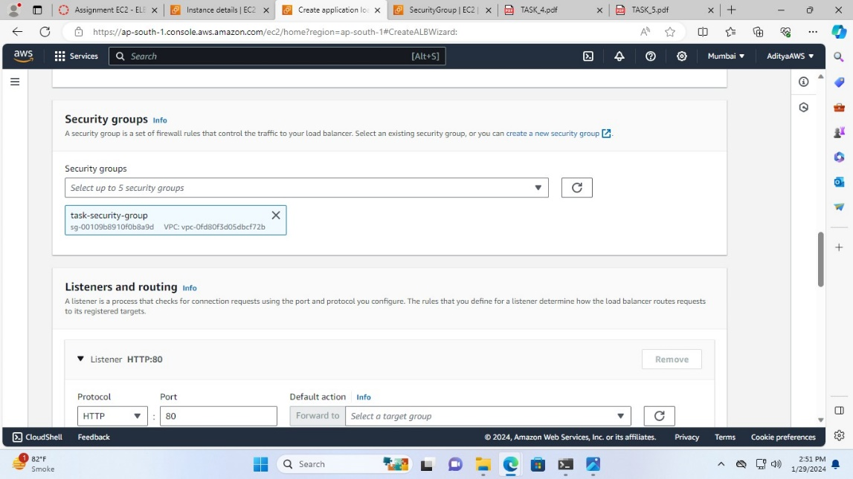

1. In listeners and routing click on “Create target group”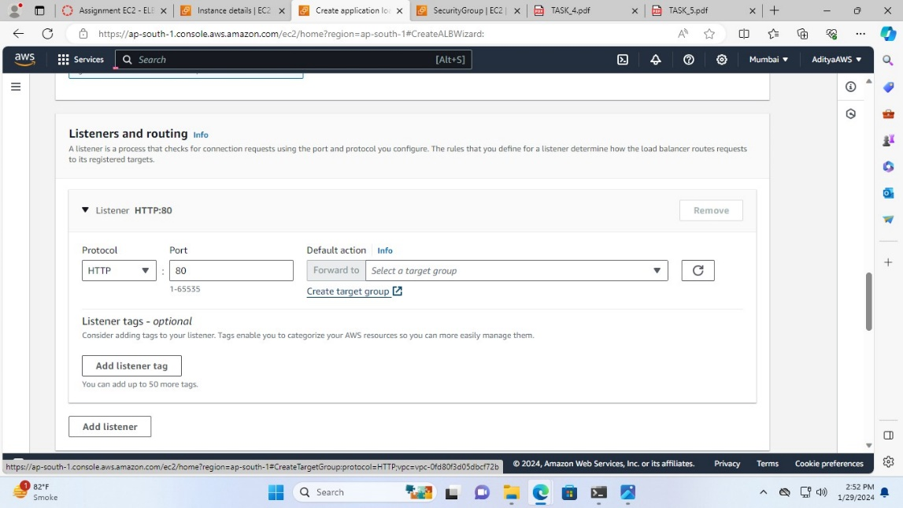
2. Choose Instances in target type

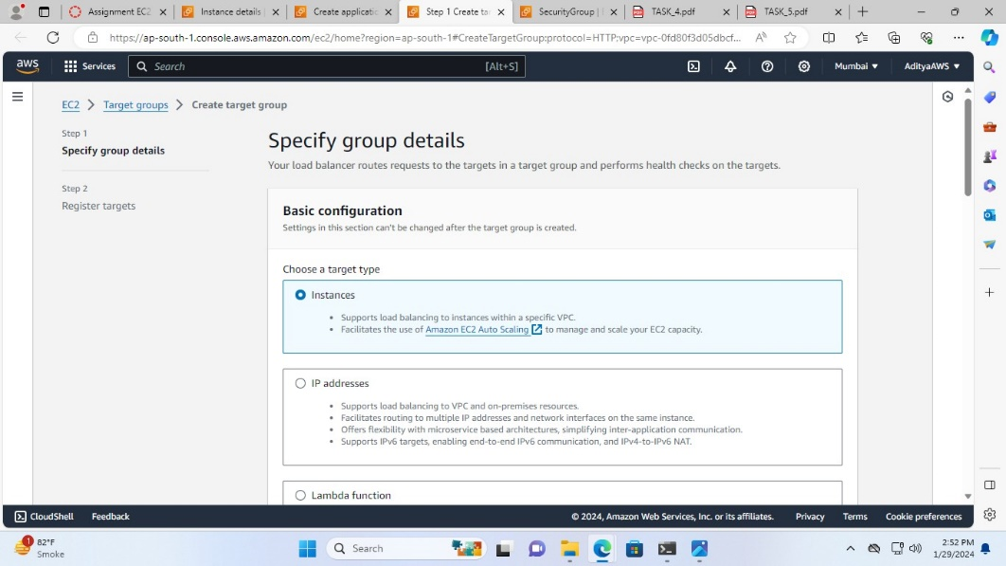

1. Name the target group (Task-target-group) and leave other sections as it is and click “Next”

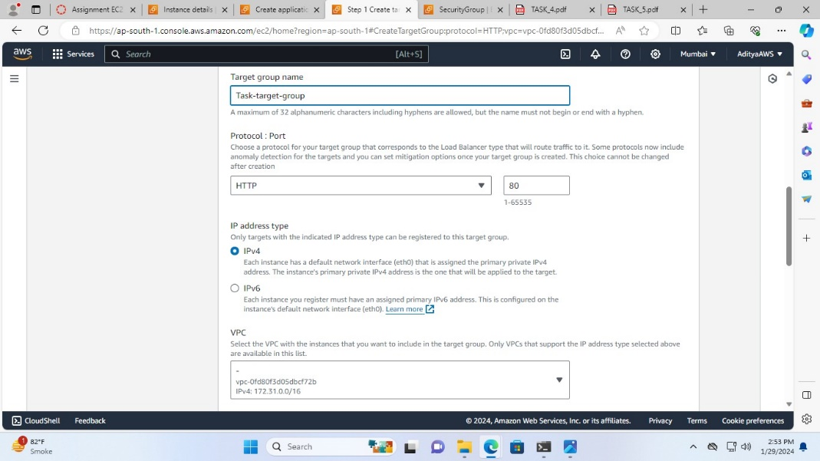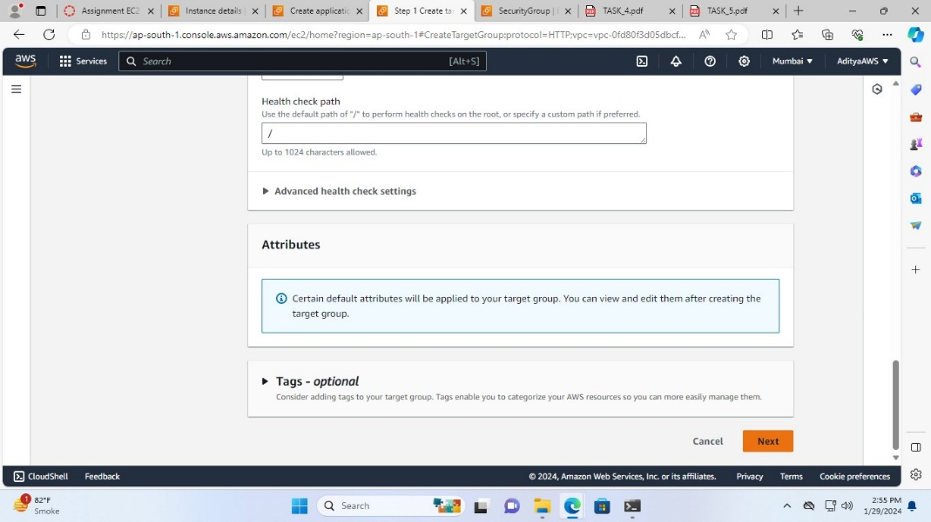

1. Now, select test1 and Test2 instances, click on “Include as pending below” and lastly click on “Create target group”

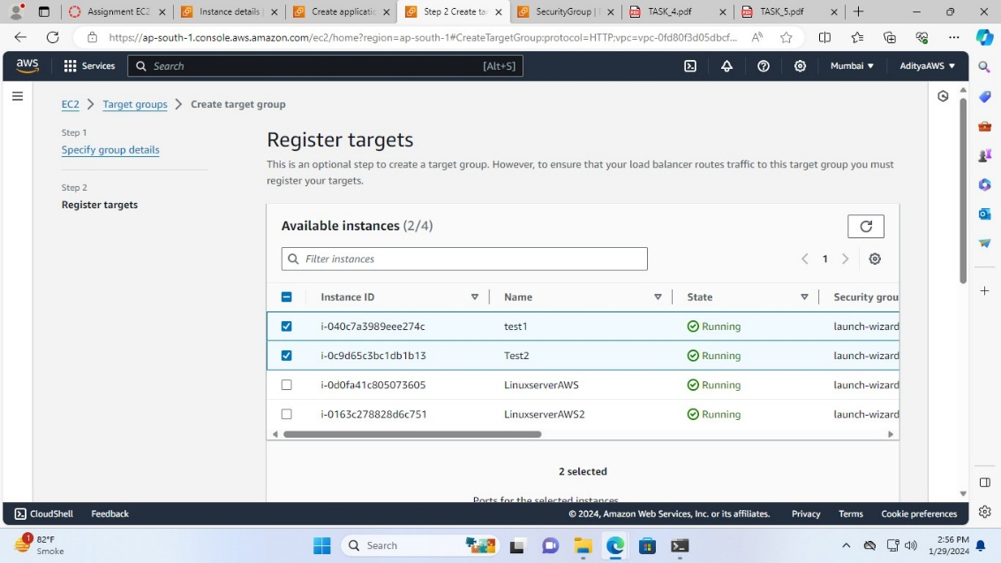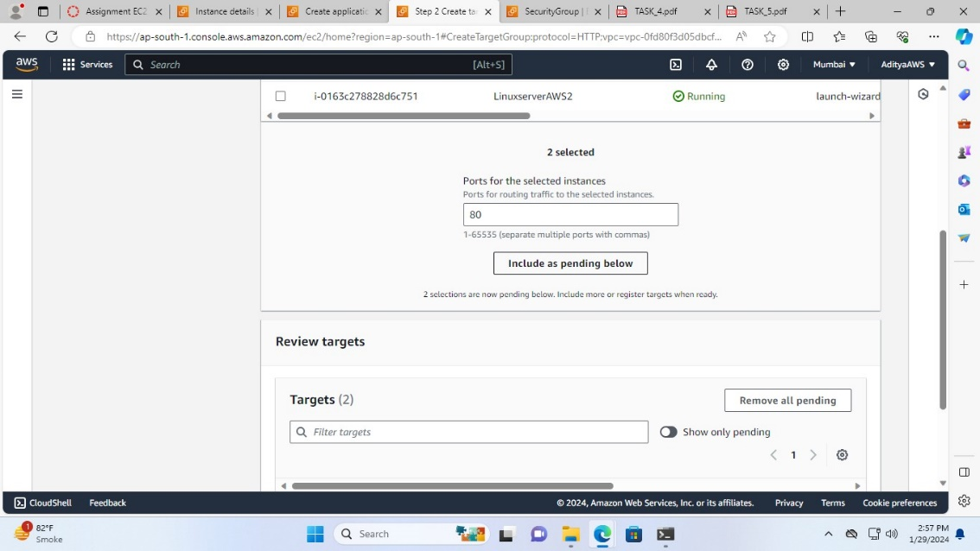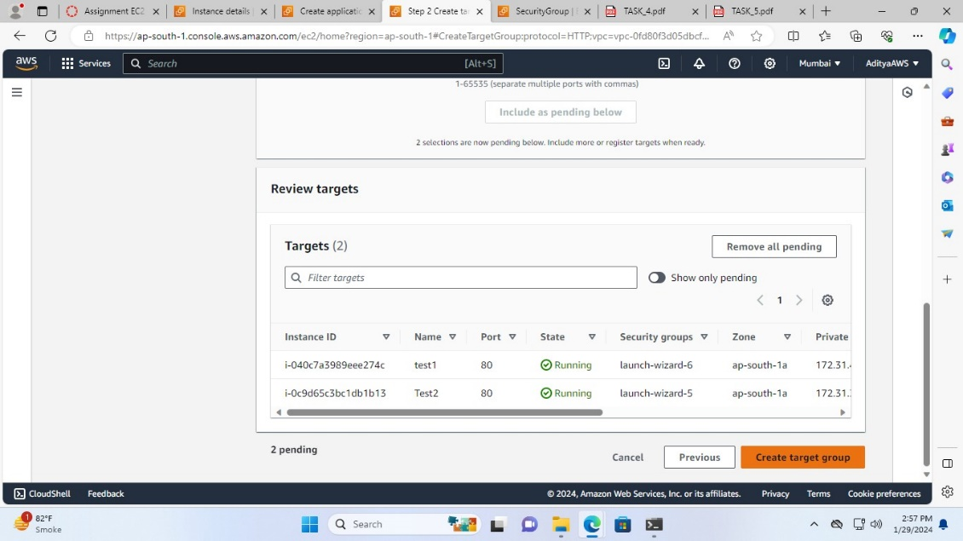

Target group created successfully

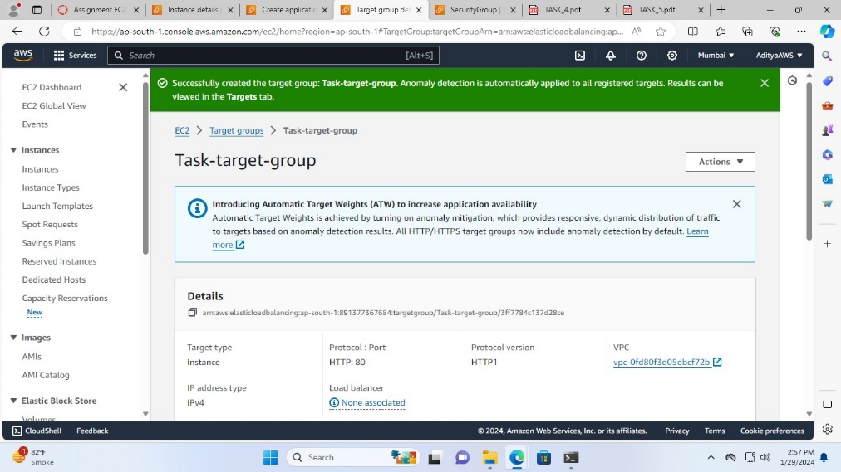

1. Select this target group (Task-target-group) in the target group

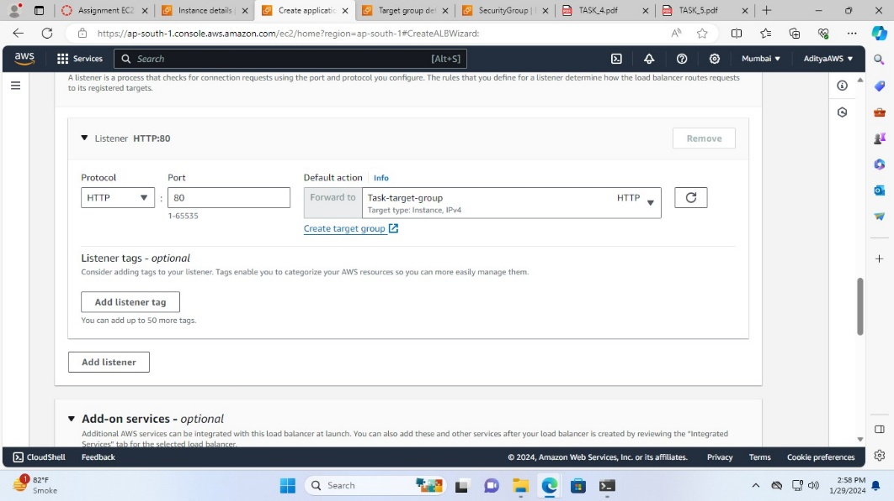

1. Click on “Create Load Balancer”.

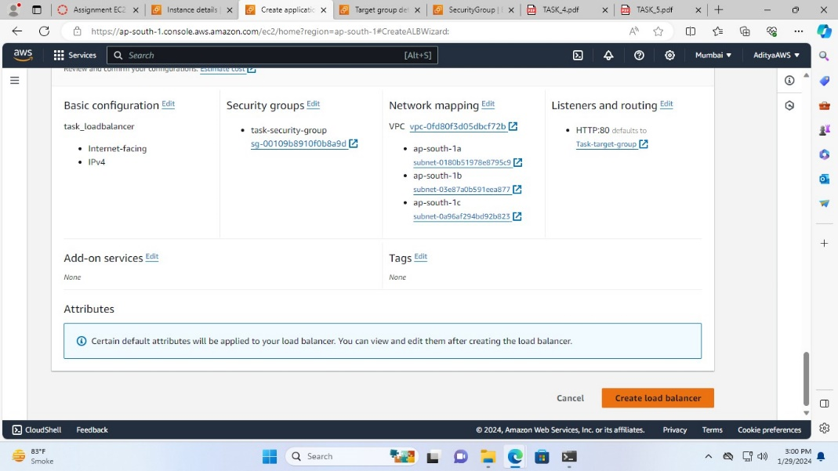

Successfully created load balancer

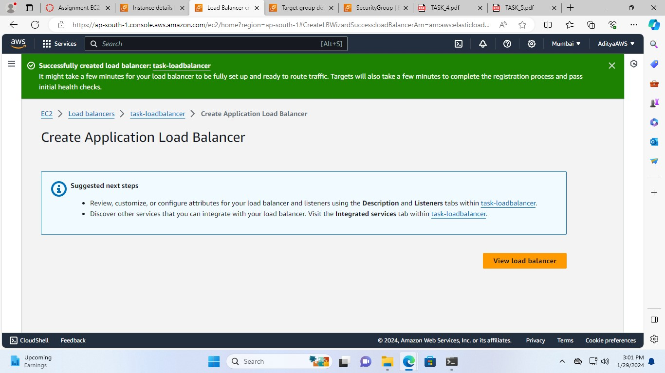

1. Now, checking the load balancer on the browser with the DNS name.

